**USER MANUAL**

**This Is A User Manual for The Website of COURIER MANAGEMENT SYSTEM Which Was Made by The Students of Aptech For the Purpose of E-Project**.

**GROUP MEMBERS**

|  |  |
| --- | --- |
| Student1432047 | HAREEM REHAN AFZAL |
| Student1432461 | ABDUL BASIT |
| Student1432059 | IBRAHIM KHATUDA |
| Student1432035 | WAJIHA NADEEM |
| Student1432254 | MUHAMMAD HASSAN |

**FACULTY :Miss Bakhtawar Siraj**

**BATCH CODE :2211B2**

**CURRICULUM :7062**

**HOME PAGE**

**In start you will see a Logo & header Image and Content and an input, from where you can track your order.**

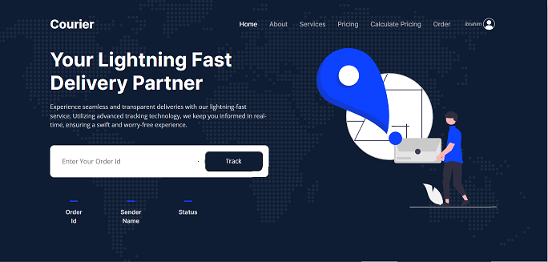

**COMPANIES**:

**This section is about “Our Companies” and from the given button you can view the current charges of these companies.**

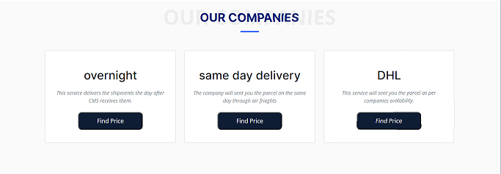

**SERVICES:**



**This page is “About Us” where you know more about our site.**

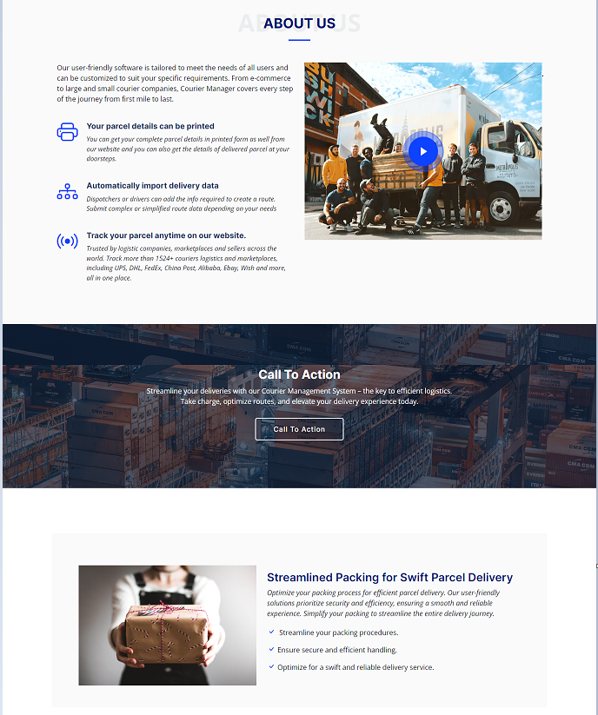

**This section provides answers to commonly asked questions about our services.**

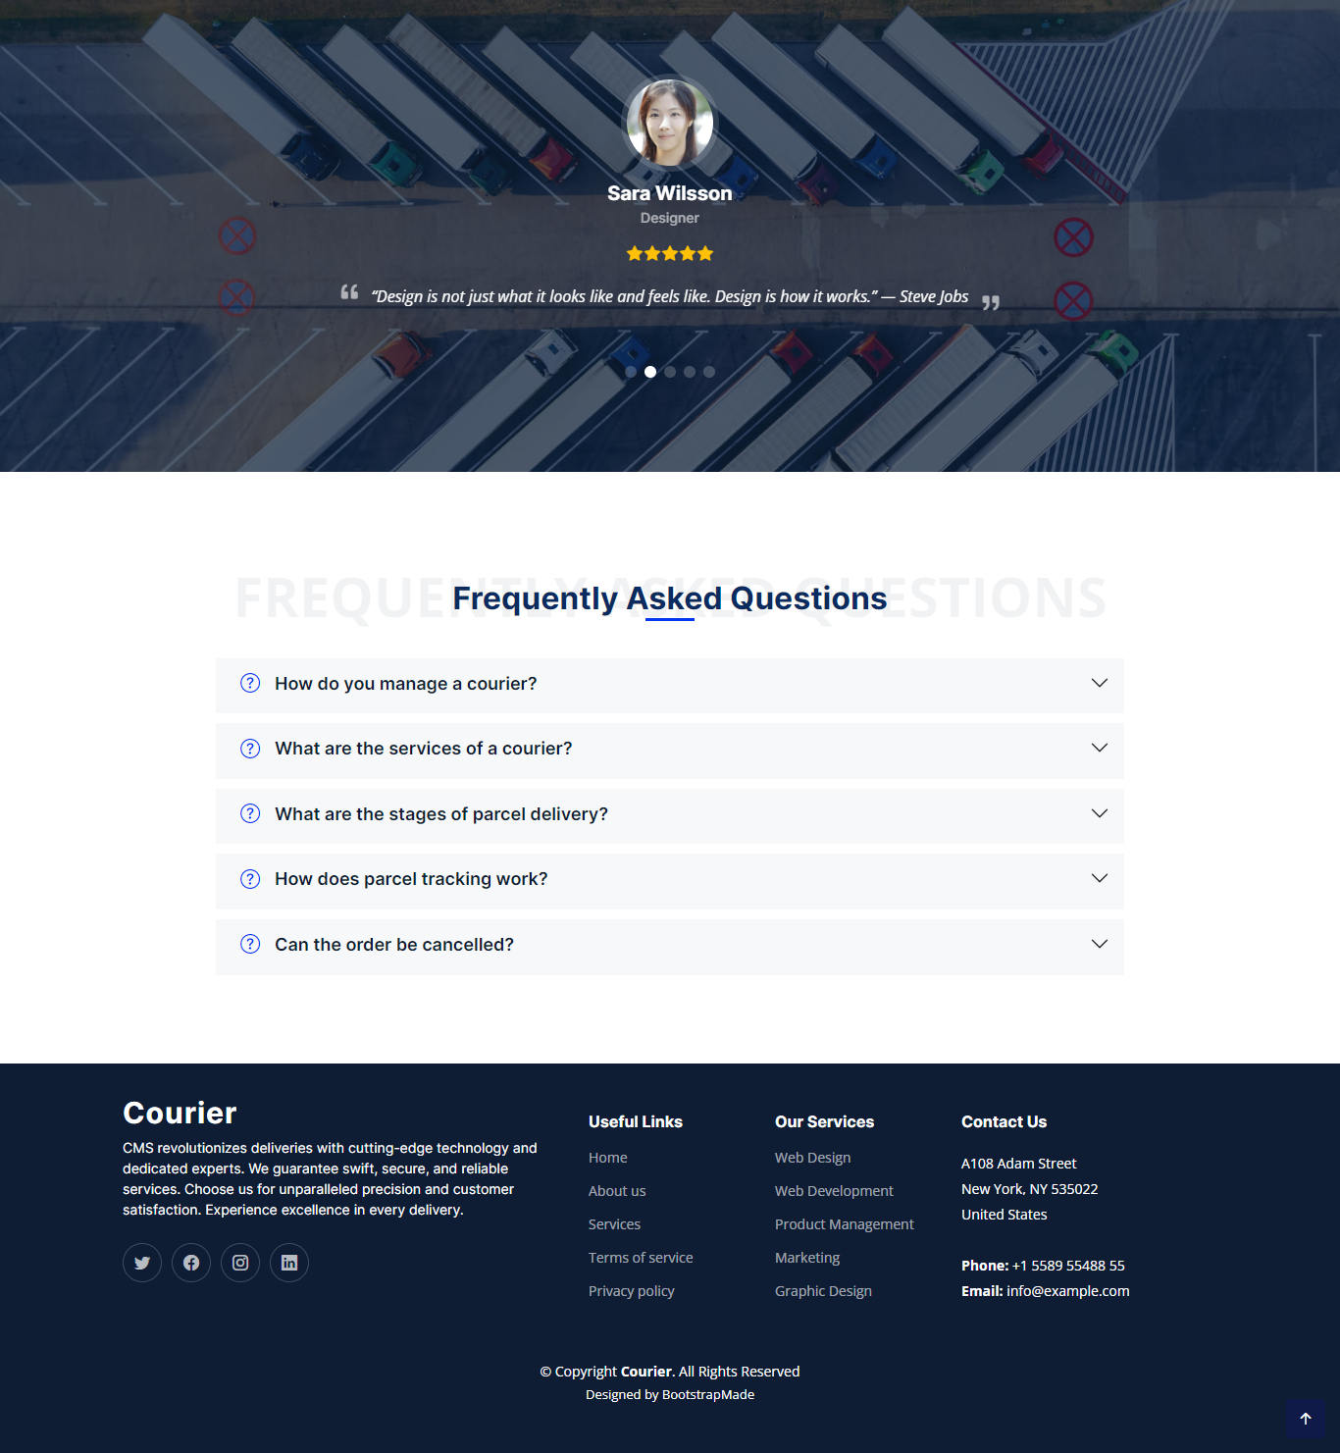

**FOOTER:**

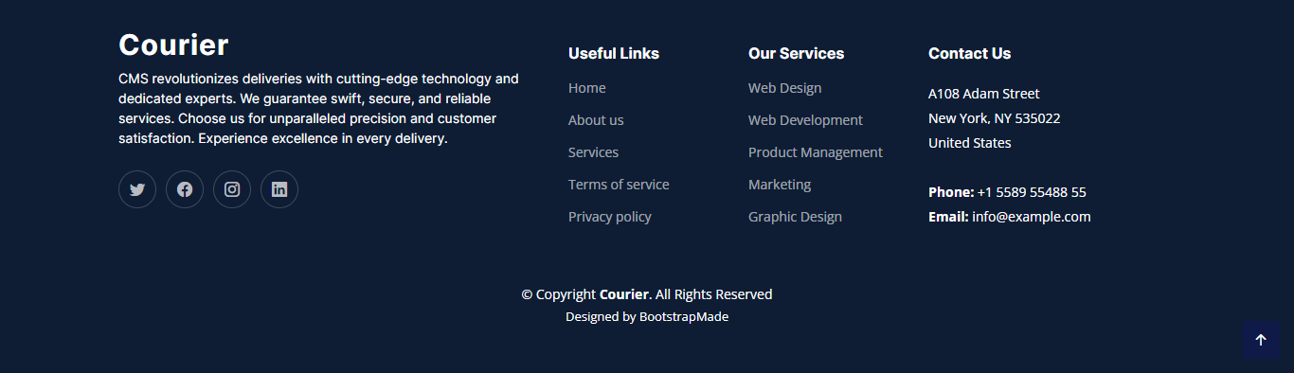

**And If you have already signed in then there’s LOGIN page:**

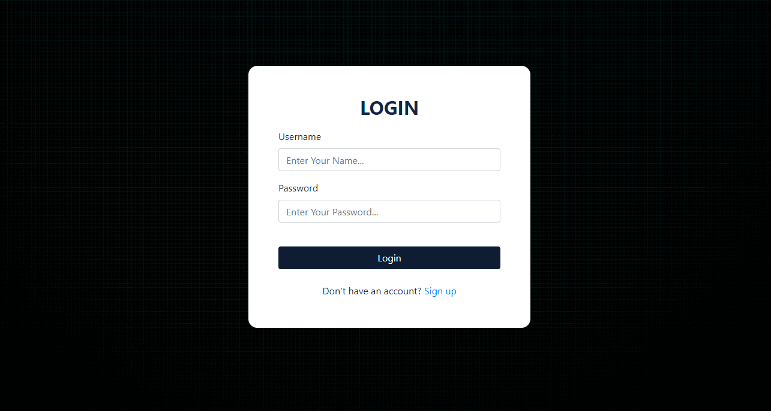

**This is how our site looks after completing all work .**

**I Hope You Like it Too :)**

